12

**Summer Spoken English**

**Intermediate**



**Contents**

Meeting New People 2

Complicated Families 2

Going to a Party 2

Clothing 3

Sports 3

Human Body 3

Biology 3

Geography 3

Weather 3

Working for a Living 3

Automobiles 3

Around Town 4

Music 4

Crazy Food 4

Computers 4

Meeting New People

**Pre-Discussion Questions**

1. Where do you go to meet new people?
2. How do you meet new people?
3. Can you know if you like someone in the first five minutes?
4. What do you say when you meet new people?
5. Do you tend to be more shy or outgoing? Why?
6. How do you start a conversation with new people?
7. What are some things you shouldn't ask people you just met？
8. How important are first impressions to you?

**Vocabulary**

|  |  |  |  |
| --- | --- | --- | --- |
| What’s up? | How’s it hanging? | Have a good one! | Sup? |
| Take it easy! | How are you? | Peace | I’m out of here |
| Yo, What’s cookin? | Same ole’ Same ole’ | Catch ya later. | I’ve got to run |
| Hope to see you soon | Well I better get going | It’s been going. | How do you do? |
| Good bye | Not if I see you first | Don’t be a stranger | Give me a buzz |

**Vocabulary Check Activity**

1. Look at the words above, which of these do you say when you meet someone? Which do you say when you leave someone? Which of these words are responses to questions or phrase?
2. Which words do you think are spoken English? Which are more formal?
3. Why does English have so many ways to greet someone?

**Reading (Listening)**

**1. Listen and Ask Questions**

Other people like to know they're being heard and that their ideas are appreciated. By being a good listener, you let others know that you value what they have to say and who they are.

You can let others know you're paying attention by making eye contact while they're speaking, then asking a question or two about what they're saying. If the conversation goes well, ask the person for his or her phone number or email, then make plans to hang out.

**2. Give a Compliment**

Everyone loves an ego boost. Noticing something you like about someone and sharing it with him or her is a great way to make a connection and start a conversation.

When giving a compliment, be honest and genuine. Even if you're complimenting something very small—like the color of the person's shoes—it's likely to be appreciated. You might even receive a compliment in return!

**3. Detach Yourself from Technology -- Temporarily**

You're less likely to notice who's interested in you if you're constantly checking your email, voicemail and text messages. Being online or on the phone also sends the message to others that you're unavailable.

Put away your cell phone from time to time and take a look around. Who seems funny or interesting? Which people in the room have you never talked to? Who pays attention to your ideas? Make a mental note and spend a little time getting to know these people face-to-face.

**4. Form a Study Group**

Does your math teacher give super-hard exams? Is your history teacher always giving pop quizzes? Round up a few others from your class to study together each week. Ask your teacher if you could pass around a sign-up sheet or make an announcement about the group after class.

When your group gets together, share notes and chat about class. Find out what your classmates like about the teacher and what they can't stand. Make flash cards together or quiz one another. Bring snacks and share what's going on in your life. You'll have new friends before you know it.

**5. Laugh**

Letting others know that you think they're funny makes them feel good and it shows them you're interested in what they think. It also shows you have a good sense of humor, which is one of the top things teens look for in a person, whether it's a best friend or a boyfriend or girlfriend.

**Reading Questions**

1. Why is it important to give compliments?
2. How can making a study group help you make friends?
3. Which advice above is the best? The worst?
4. Do you have any other suggestions on how to meet or make new friends?

**Group Project**

1. First work in pairs to create a character for each other. One partner you should describe the character that the other partner is going to be. Your conversation should like this:

Person 1: “Well, Ok you are 35 years old, you were born in Sichuan, you had three really good friends when you were young, but one of them died so you moved away. When you were 20 you came to Taiyuan and started working as a construction worker.”

Person 2: “really? Well then am I still working as a construction worker now? Am I married?”

Person 1: “no you stopped working in construction when you married this rich man’s daughter, now you don’t need to work, but you just found out that your wife’s father is a bad man”

Person 2: “Well, why did I stay in Taiyuan, I mean why didn’t I go back to Sichuan?”

Your conversation should continue like this until you know everything about your new self, then you should switch places.

1. After you know everything about each other you will need to go around the classroom and interview three people and find out what their new personalities are like. Make sure to take notes as you will need to report to the class who you met.

When discussing your new characters you should discuss all of the following information:

1. Family Background
2. Age
3. Occupation
4. Personality
5. Hobbies
6. Fears

**Writing**

Imagine the character that you have just become has just met one of your real-life best friends. Write a dialogue about what they would say. You have five minutes to complete this task.

**Homework**

1. Write one page about the character that you created in class.

# Complicated Families

**Pre-Discussion Questions**

1. Do you have a complicated family?
2. Are you pressured by your family to act in a certain way?
3. Are your parents strict?
4. Do you get along well with your family?
5. Do you usually have any influence on family matters?
6. Do you have a curfew?
7. Do you often argue with your mother or father? What about?
8. What do you and your family like to do together?

**Vocabulary**

|  |  |  |  |
| --- | --- | --- | --- |
| Second cousin | Step-Dad | Ex-wife | Brother-in-law |
| Younger-brother | Step-Mom | Ex-Husband | Sister-in-law |
| Elder-brother | Nephew | Granddaughter | Son-in-Law |
| Younger-sister | Niece | Grandson | Daughter-in-Law |
| Elder-Sister | Twin | Widow | Widower |

**Vocabulary Check Activity**

1. __________________ is your uncle or aunts daughter.
2. __________________ is your father’s cousin.
3. __________________ is your brother’s wife.
4. __________________ is your daughter’s son.
5. __________________ is your mother’s new husband.
6. __________________ is your daughter’s husband.
7. __________________ is a woman whose husband has died.
8. __________________ is the person that man used to be married to.
9. __________________ are two people who look the same.
10. __________________ is your aunt or uncle’s daughter.

**Reading (Listening)**

Maria had to buy food for herself and her son. Divorced for ten years, she was used to doing the shopping for her son. He was a junior in high school, which meant that he would be entering college in two years. Then she would be shopping only for herself. She felt sad when she thought of this. She hoped that he would attend the local junior college and then transfer to a university. That way he could continue to live at home for another two years. She loved him, and dreaded the day that he would no longer be her daily company.

Maria drove to Costco, a chain store that sold food in bulk packages. By selling in bulk only, the store helps its customers save money. She parked far from the entrance. That meant a longer walk, but also a faster exit from the parking lot. She grabbed one of the big shopping carts outside and pushed it into the store. Her purse stayed tightly hung over her shoulder. Surprisingly, the store wasn't too crowded.

In the produce section, she examined nine packages of seedless green grapes before she found one that she liked. She carefully selected some bananas, apples, and other fruit. But she couldn't find her son's favorite brand of tangerines. On the way home, she planned to stop at another market or two until she found them.

**Reading Questions**

1. What do you think happens next in the story?
2. Try and guess the following words from context, then check with a friend for the answer, finally double check with the teacher to make sure you understand the word.

_____________ bulk

_____________ company

_____________ crowded

_____________ divorce

_____________ dread

_____________ entrance

_____________ grab

_____________ hang

_____________ junior

_____________ package

_____________ produce

_____________ purse

_____________ surprisingly

_____________ transfer

1. What is a local junior college? How is it different than a normal college? Why does Maria want her son to attend a local junior college?
2. Who is Maria shopping for?
3. What should the title of this story be?
4. How do you think Maria and her son’s relationship has changed since Maria got a divorce?

**Group Project**

1. In groups of three talk about your family. First you should tell how many people are in your family then you should include the following information about each person.
   1. How old are they?
   2. What do they look like? (Appearance)
   3. What are they like? (Personality)
   4. What are their hobbies?
   5. What do they do?
   6. What is their favorite food?
2. The other two people in the group should ask one follow up question for each person that their partner describes. For example:

Person 1: My father is 40 years old. He is tall and handsome. He is very and kind and outgoing, he loves to go fishing. Now he is a banker at China bank. He loves to eat Pizza.

Person 2: Where does he go fishing? 🡨 Follow up question

Person 1: He goes fishing at yinze park.

Person 3: Does he like working at the bank? 🡨 Follow up question

Person 1: Yes he loves working at the bank.

**Writing**

You have five minutes to write about one person in your family. Do not write any names and do not tell if it is a boy or girl. After you finish writing hand your paper to the teacher. He will read what you wrote and the class will try and guess which family member it is.

**Homework**

1. Interview one of your parents about your great grandparents. Write ½ a page about one of your grandparents.

# 

# Going to a Party

**Pre-Discussion Questions**

1. Do you go to parties in your free time?
2. What do you do at a party?
3. How often do you go to parties?
4. Is there food at the parties you go to?
5. Do you like to gossip at parties?
6. Who would you invite to your parties?
7. If you go to parties do your parents know about it?
8. What do you like about parties?
9. Where would you like to have a party?

**Vocabulary**

|  |  |  |  |
| --- | --- | --- | --- |
| Decorations | Set a date | Refreshments | Dinner parties |
| Themed parties | Social gathering | Throw a party | Have a party |
| Invitation List | Party Animal | Have a blast | Turn it up |
| Show up | Going away party | Costume Party | Dance |
| Barbecue | Cookout | Family get-together | Feast |

**Vocabulary Check Activity**

1. What is the difference between a themed party and a costume party?
2. What is a party animal?
3. What type of decorations do you need at a party?
4. What kind of refreshments do you need at a party?

**Reading (Listening)**

**How to throw yourself a Party**

**Prepare.** Pick a large empty room. Lock the door, and tidy it up. This will reduce the mess when clean up afterwards. Then plump the pillows on the couch/bed, throw out a few throws, and clean off the coffee table/night table/end table. Go into the kitchen and pick out a few snacks, but don't spend so much time making them. Set the refreshments up on a table on the other side of the room. Bring paper towels for spills.

**Decorate.** Get out some streamers, balloons, or even candles. Light the candles and put them around the room. Throw the streamers through the spaces between the fan blades. Tie balloons to ribbons and tie them to the legs of chairs, tables, beds, stuffed animals, etc. If possible, dim the lights.

**Entertain.** Put your iPod into your iHome, or place a CD into a CD player. Play one of your most favorite wild and fast-beat songs. Dance like you've never danced before! When you are tired, pick out one of the drinks you brought as refreshments, sit down, and rest, while watching your favorite movie!

**Fun & Games!** Play Truth or Dare-- with yourself! Another game is Time Ticker. Count *down* to five. In that time, you have to complete one task. Pretend that if you don't do it in that five seconds, a bomb will go off. Then do two tasks in the next countdown, then three. Keep on going until your tasks exceed 5 seconds. Play online game if a computer is in the room.

**Second go-round.** Pop in another CD and dance your heart out! Pretend you're in a dance competition! If you win, give yourself another piece of cake/cookie, or a piece of candy!

**Clean up.** Tidy things up. Seal food, and put the lids on bottles. Bring dishes to the kitchen, and vacuum the floor.

**Beauty sleep!** Put in a hip song, blast it so that you can hear it from the bathroom! Brush your teeth, comb your hair, and get in your comfy pajamas. Then grab a blanket & pillow, or sleeping bag. Grab a spot on the floor, or sleep on the couch. But this is a party, possibly a sleepover! Don't sleep on the bed! Before you sleep, set in a peaceful, quiet CD and...

**A Wake-up call.** ...Set your alarm to 3 o'clock-- at night! Then drift off to sleep, and then wake up for a Refrigerator Raid! Grab lots of snacks, go to your room, and brainstorm! Maybe you can play a prank on neighbors or someone else in the house!

**Condemned!** After getting caught for your sneaky plan, go back to bed and wake up late! You can sleep in, can't you?!

**Reading Questions**

1. Would you ever have a party for yourself? Why or why not?
2. What kind of games can you play at a party?
3. Do you know any of the party games below?
   1. Truth or Dare
   2. Hide N Seek
   3. Pictionary
   4. Spin the Bottle
4. What kind of music should play at a party? Why?

**Group Project**

1. In groups of two or three plan a themed party. You should include the following information.
   1. Total cost of the party
   2. Theme of party
   3. List of decorations that need to buy
   4. List of refreshments that you are going to provide
   5. Choose 5 songs to start the party: what type of mood are you trying to set with these five songs?
   6. Draw a sample invitation card
   7. Invitation list of at least 5 famous people, be ready to explain why you invited them.

**Writing**

Think of a process that takes four steps then write about it using the blank space below.

Process Ideas:

How to cheat on a test

How to make a sandwich

How to rob a bank

How to do the laundry

1. First, _________________________________________________________________
2. Then, __________________________________________________________________
3. After that, ____________________________________________________________
4. Finally, _______________________________________________________________

**Homework**

1. Write up a party plan, use the information you discussed in your group project.

# Clothing

**Pre-Discussion Questions**

1. Do you like shopping for new clothes?
2. Do you have a lot of cloth?
3. Do you often buy new clothes?
4. Do you think it is important to wear fashionable clothes?
5. Do you wear the same color clothes now that you wore ten years ago?
6. Have you ever made your own clothes?
7. What do you think of people who dye their hair green?
8. Do you think high heel shoes are bad for a person's health?
9. What kind of clothes are in fashion now?
10. What kind of clothes do you usually wear?

**Vocabulary**

|  |  |  |  |
| --- | --- | --- | --- |
| Spaghetti straps | Fishnets | Pantyhose | Fly (zipper) |
| Wife beater | Cargo Shorts | Kicks (decked out) | Jeans |
| Overalls | Overcoat | Pullover | Scarf |
| Mini-skirt | Tracksuit | Sandals | Vest |
| Cap | Leather | Wool | denim |

**Vocabulary Check Activity**

Match the above vocabulary words with the pictures below.

|  |  |  |  |
| --- | --- | --- | --- |
|  |  |  |  |
|  |  |  |  |
|  |  |  |  |

**Reading (Listening)**

TEEN STYLES

Can you identify these tribes with their descriptions?

Read and match each paragraph with its title and photo.

**Gangstas Posh Chavs Goths Nerds Geeks Skaters Babes**

**1.** ..........................................................................

These people look sad most of the times. They wear black clothes: leather jackets, corsets, long skirts... Their hair is usually long, and they wear a lot of black-and-white make-up. They like a special kind of rock and heavy-metal music.

2. .............................................................................

These people are mostly girls. They only read fashion magazines. They spend hours in the bathroom putting on make-up and perfume. Mini-skirts, high-heeled shoes and tight T-shirts with big necklines are their favourite clothes. They would like to be super-models or famous actresses.

3. ...........................................................................

Star Wars, Star Trek, manga comics, role games, computers, etc. are these persons’ favourite activities. They seem to be interested in strange things that nobody else likes. They dress in T-shirts with unusual prints and jokes that only they understand. However, they like to get dresses like their favourite comic or film characters in parties.

4. ......................................................................

The gang is these people’s reason to live. They always go out in groups and are loyal to their leader. Their clothes are normally casual and sporty: wide jeans, basketball t-shirts, trainers, baseball caps,... Their favourite music styles are rap and hip-hop.

5. ....................................................................

The thing that these people enjoy the most is studying. They wear old-fashioned clothes and, sometimes, also glasses. They are usually quite intelligent. You can easily see them working in their computers and discussing about Maths or Science. However, they are normally laughed at and chased by the school bullies.

6. ........................................................................

These people always wear tracksuits, flashy trainers, fake brand clothes and lots of cheap, brilliant jewellery or “bling”. They like techno music a lot. They enjoy tunning their cars and meeting with their friends to drink alcohol, but they can be very violent if they think that you’re attacking them.

7. ......................................................................

These people are very sporty. They live literally on wheels. They use them to go by the street and to show off in front of their friends. Another of their favourite activities is painting graffitti. They wear wide jeans, caps and long chains to hold their keys.

8. ...................................................................

Money and expensive clothes are the most important things for these persons. They like spending lots of money in brand clothes and going to exclusive bars and clubs. They usually wear shirts, ultra-clean trousers and straight hair, dyed blonde if they are girls.

A.

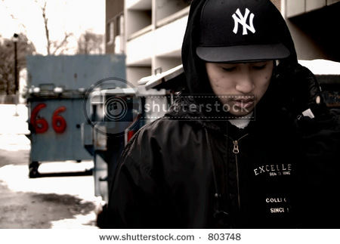

B.

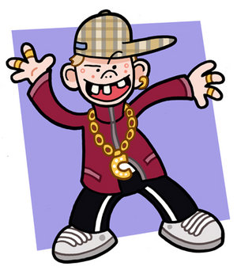

C.

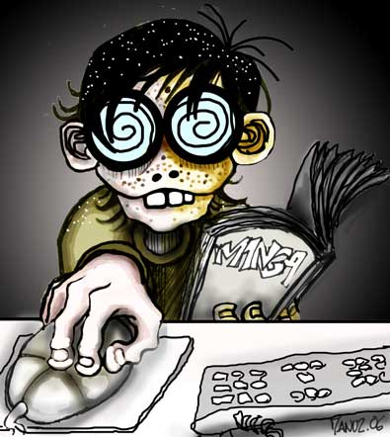

D.

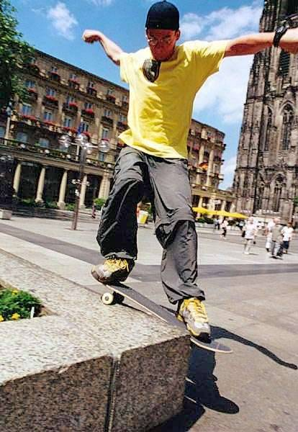

E.

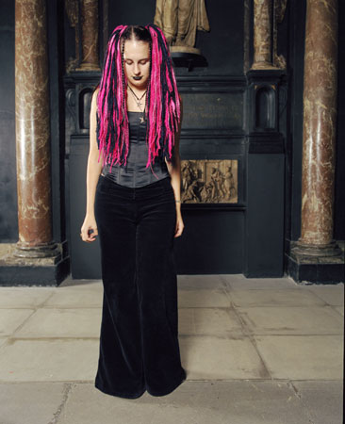

F.

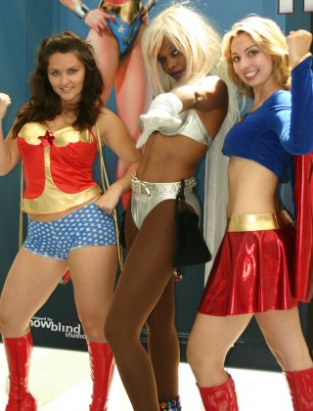

G.

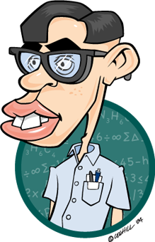

H.

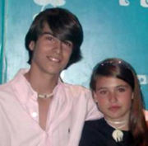

**Group Project**

1. What do your clothes say about you? In groups of 3 think about the following situations, what type of clothes would you wear for each situation and why?
   1. Funeral
   2. Wedding
   3. Party
   4. School
   5. Sick Day
   6. Job Interview

**Writing**

1. Take five minutes to describe what someone in the class is wearing. After you finish writing hand your paper to the teacher. The teacher will read the descriptions while your classmates guess who you wrote about.

**Homework**

1. In the reading you read about different styles of American teens. Write about the different types of teens in your school.

# ****Sports****

**Pre-Discussion Questions**

1. Do you play any sports?
2. Are you a member of any sports team?
3. What sport do you think is the most expensive?
4. Have you ever been to watch a professional sporting event?
5. Is it good that professional sports are so commercial nowadays?
6. What do you think is the most popular sport in the world?
7. Are you good at sports?
8. What is the most dangerous sport?
9. What new sports would you like to try?
10. Do you like to exercise?

**Vocabulary**

|  |  |  |  |
| --- | --- | --- | --- |
| Basketball | Baseball | Rugby | Athlete |
| Football | Snooker | Horse-Racing | Jockey |
| Lose | Practice | Shoot | Player |
| Circuit | Gym | Rink | Stadium |
| Course | Court | Ring | Beat |

**Vocabulary Check Activity**

1. Which of the words above describe a sport?
2. Which of the words above describe a place that a sport is played?
3. Which of the words above are verbs to describe a sport?

**Reading (Listening)**

# Top 10 Most Popular Sports in the World

**10. Golf**

Golf is considered to the game of the richest because is the most costliest sports in the world. It is highly popular in United States which has about 20,000 golf courses. The number of golf courses in Europe is far less than Unites which relates the story of popularity of Golf in Unites States.



**9. Rugby**

Rugby is a form of football that was invented in England and named after Rugby School located in England. The originating country of Rugby has lot of supporters of this game which is played in two formats called Rugby Union and Rugby League that have similarities as well as differences.

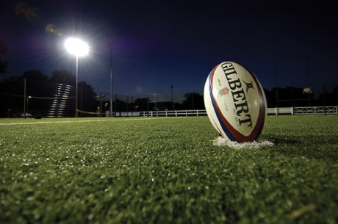

**8. Volley Ball**

Volley Ball is a six players game which is highly popular in India and Pakistan where it is played in every village at evening but Unites States takes lead in the matter of popularity. This game was invented in Unites States also. Volley Ball can also be enjoyed at beach but not in water.



**7. Hockey**

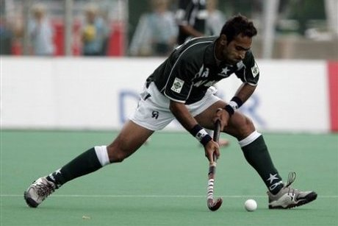

Hockey is not much popular in Unites States but all the European countries have developed the taste of Hockey. Although it is national game of India and Pakistan yet it is second most popular sports in sub-continent after Cricket.

**6. Table Tennis**

One of the fastest games of the world where one must have sharp reflexes and Chinese are up to the task. It is the national game of People’s Republic of China and Chinese players have made their nation feel proud on it’s national game because most of notable tennis players are from China.

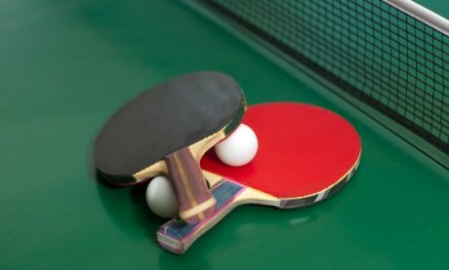

**5. Basketball**

Basketball is an American invention which requires more than average height to be able to participate in Basketball. NBA is the highly popular event where thirty professional teams compete for the title. Out of thirty teams, only one team is from Canada and the rest belongs to Unites States.

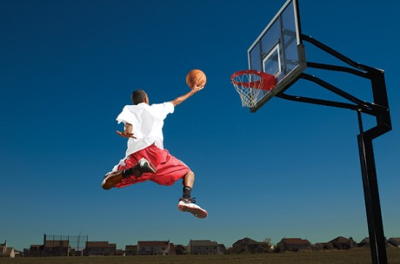

**4. Baseball**

Baseball is very much similar to Cricket. It is an interesting observation that the most of Baseball fans live in Unites States, Japan, Korea, Canada , Cuba and Mexico where Cricket is not so widely played. Baseball is played nationwide in United States as it is national game of United States.



**3. Tennis**

The modern game of Tennis which we call lawn tennis was developed in England. Tennis is not a national game of any high profile country but it has fans all around the world. The game has gained popularity in females who find it as a best sporting career in Tennis.

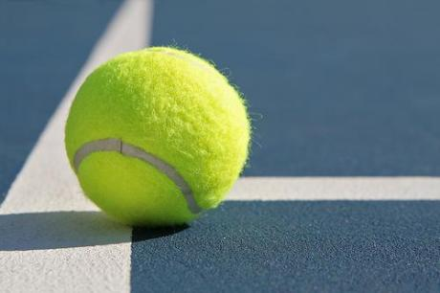

**2. Cricket**

Cricket has developed vastly with the invention of T20 because the game completes in less than 4 hours. Other formats of Cricket require more time so it was need of the hour to cut down the time period to develop the interest of people in Cricket. It is national game of Australia that has won ICC World Cup four times till now.

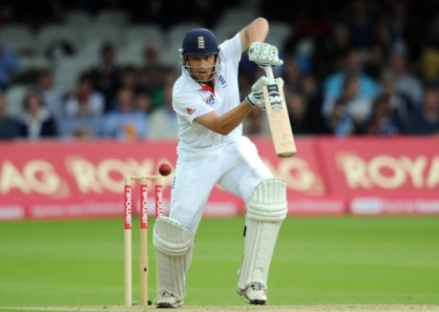

**1. Football**

The whole world agrees that Football is the most popular sports of the world because it requires a ball and eleven players per side to begin the game so it is equal opportunities for the rich and the poor. It is the national game of England but equally popular in other countries of Europe and Unites States. The game of Football is not so lengthy that is the reason of its popularity in whole world.



**Reading Questions**

1. Which sports do you not know?
2. Do you agree with the ranking of these sports? Why or why not?
3. Why do you think soccer is the most popular sport?
4. Are there any sports that are not ranked that you think should be ranked?

**Group Project**

1. In groups of 2 or 3 invent a new sport. You should include the following information.
   1. Name of the sport
   2. How to win/lose
   3. Basic rules to the sport
   4. Equipment needed for the sport
   5. Where is the sport played?

**Homework**

1. Write 1 page about the sport that you and your group invented.

# Human Body

**Pre-Discussion Questions**

1. How many parts of your body can you name?
2. Do you exercise?
3. What kind of exercise do you do?
4. What are some important things about your body?
5. Do you ever get headaches?
6. How do you take care of your body?
7. Have you ever had braces on your teeth?
8. Have you ever broken a bone?
9. What's your blood type?
10. What part of your body is the weakest?

**Vocabulary**

|  |  |  |  |
| --- | --- | --- | --- |
| Calf | Thigh | Biceps | Abs |
| Forearm | Upper arm | Armpit | Chest |
| Waist | Buttocks | Hip | Knee |
| Back | Shin | Knuckle | Fingernail |
| Palm | Forehead | Cheek | lips |

**Vocabulary Check Activity**

Label the Body with the words above

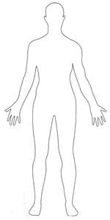

**Reading (Listening)**

Ten tips on how to stay healthy

**Tip #1. Eat a Nutritious Breakfast**  
After a long night’s sleep it is important to refuel. It will help you do better in school. Some ideas for quick, healthy breakfast: Peanut butter on toasted whole-grain bread, Yogurt with fruit, Cheese slices on toast and Fruit on cereals.

**Tip #2. Eat a variety of foods.**  
Your body needs nutrients and many different vitamins and minerals from a variety of foods. Balancing food choices from the Food Guide Pyramid and checking nutrition labels will help you to get the nutrients you need.

**Tip #3. Get moving....don’t be a couch potato**  
Walk, bike or jog when going somewhere. Climb stairs instead of taking an escalator. Try to do something active for a total of 30 minutes every day.

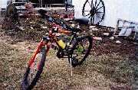

**Tip #4. Participate in activities you enjoy.**  
Always start with warm-ups to get the muscles going. Do 20 minutes of an aerobic activity followed by activities that will make you stronger like push-ups or sit-ups.

**Tip #5. Choose healthy snacks.**  
It is wise to choose snacks from different food groups. Some choices would be: graham crackers, an apple or celery sticks with peanut butter and raisins.



**Tip #6. Include whole grains and fiber in your diet.**  
Try breads such as whole-wheat, bagels and pita. Spaghetti and oatmeal are also good choices.

**Tip #7. Participate in physical activities at school.**  
This would include physical education and sports. It will make you feel good about yourself.

**Tip #8. Drink plenty of water.**  
Your body is 65% water. That shows how important water is to your body. Make sure you drink a total of 8 glasses of water each day. That can include water from foods such as fruits.

**Tip #9. Include others in your activities.**  
Take a dog for a walk and or walk or workout with a friend.

**Tip #10. Having FUN is important.**  
Try new things, this can be in activities or food. Never be afraid to try....who knows you might just like it. And your body will thank you in the end.

**Reading Questions**

1. How many of the tips above do you use now?
2. Do you think the tips are helpful? Why or why not?
3. Some people think that being healthy is not worth enjoying good food and being lazy, do you agree?

**Group Project**

1. I have a friend who is overweight and out of shape. In groups of two or three make a one-month plan to get him back in shape. Your plan should include the following items.
   1. A weekly exercise schedule
   2. A weekly diet plan

**Writing**

1. Create an alien. You have five minutes to describe his physical features. For example:

It has a big green head with two red foreheads and five eyes. Its neck is as big a man’s leg. It has five arms and each arm has four hands with 10 fingers, but no knuckles.

When you finish writing hand your paper into your teacher. You have five minutes to finish.

**Homework**

1. Write a weekly diet plan for yourself.

# Science

**Pre-Discussion Questions**

1. How does science make our lives better?
2. How does science make our lives worse?
3. What is the difference between a theory and a fact?
4. What are the top five inventions in human history?
5. What are the top five discoveries in human history?
6. What inspires inventions?

**Vocabulary**

|  |  |  |  |
| --- | --- | --- | --- |
| Inventor | Researcher | Appliance | Fax |
| Discover | Experiment | Lab | Portable |
| engine | Test | Scientist | technician |
| Microscope | Machine | Invent | Lab coats |
| battery | Theory | gadget | Research |

**Vocabulary Check Activity**

1. ________________ is a person that invents things.
2. _______________­­ is an idea that hasn't been 100% proved.
3. ________________ is something that scientist do to try and prove a theory.
4. ________________ is a person that searches for information.
5. ________________ is a person that works in a laboratory assisting a scientist.
6. ________________ is something that gives an appliance power.
7. ________________ is something that makes a machine work.
8. ________________ is something that technicians wear in the laboratory.
9. ________________ is the short name for a laboratory.
10. ________________ is a word that means to be able to move.

**Reading (Listening)**

Weird Inventions

**All in one farm tool**

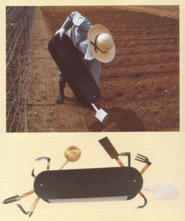

One item that has a shovel a pick and pretty much anything you’d need to do your farming.

**9. Umbrella for shoes**

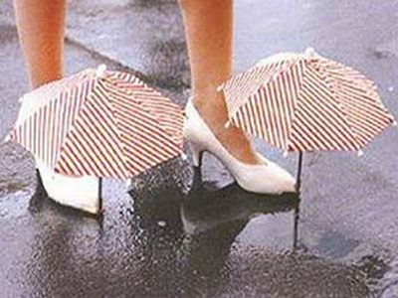

It prevents my sandals and at the same time makes me look stupid. I love when people gape infinitely until their jaws fell.

**8. Shoe broom**

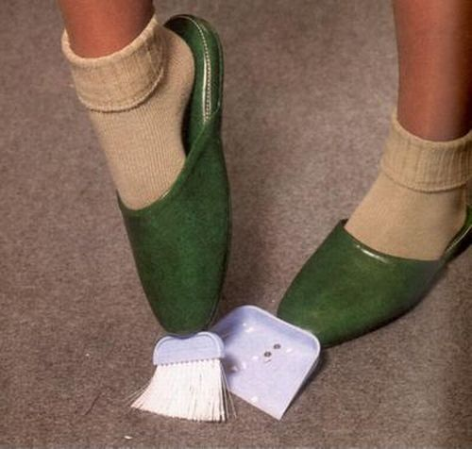

It’s more of an exercising tool than a cleaning broom. Whatever…. it surely looks cool.

**7. Ctrl+Alt+Del Handle**



The designer of this machine tool was so frustrated with pressing Ctrl+Alt+Del after any command he gave to his Windows 98 box, that he invented this machine to do it for him.

**6. Butter Stick**

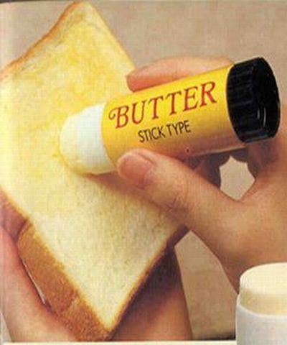

This one is not that silly after all. I would definitely love to own this. I wonder if the next version will be loaded with a heating device for the frozen butter in winters.

**5. Steering tray**

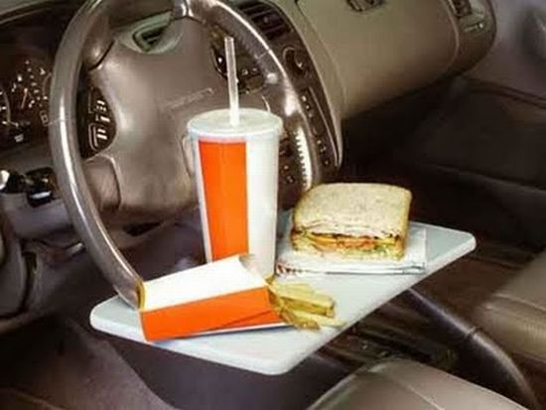

This is a good bet if you have a fast metabolism and need to eat frequently while driving.

**4. Food Cooler**

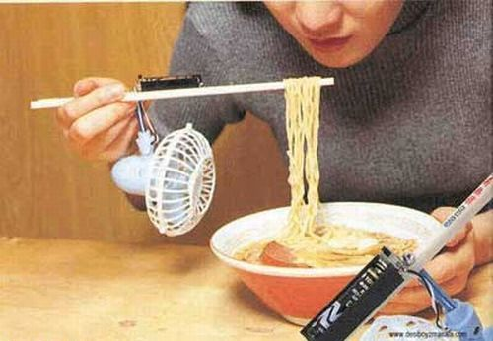

Makes using chopsticks even more difficult.

**3. Umbrella Tent**

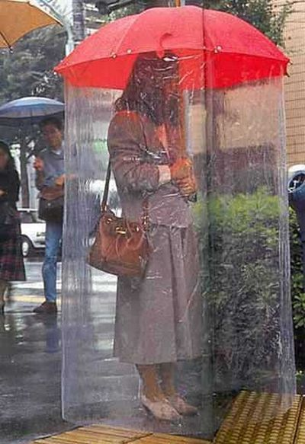

This one looks smart. An umbrella as we know it should have been like this. I wonder if this woman had to talk to someone what she would do.

**2. Sleep-Anywhere-Helmet**

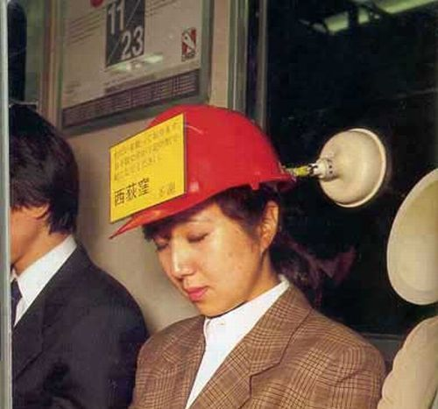

**Reading Questions**

1. Which of the above inventions do you think is the most useful?
2. Which of the above inventions do you think is the least useful?
3. Who do you think would buy each of these inventions?
4. Can you think of any other stupid inventions?

**Group Project**

1. In groups of two or three invent your own item. You should include the following information.
   1. What is the name of the invention?
   2. What does it do?
   3. Who will want to use it?
   4. How much will it cost?
   5. What problem will it solve?
   6. What items will it replace.

**Writing**

1. You have five minutes to write a newspaper ad for either the object that you just created in your group or for one of the inventions above.

# Geography

**Pre-Discussion Questions**

1. Would you prefer to live in the forest or the mountains?
2. Would you prefer to vacation on the beach or in the jungle?
3. What’s the difference between the jungle and the forest?
4. What is the most comfortable climate in your opinion?
5. What is the worst climate in your opinion?
6. What type of people live near the beach? In the forest? In the desert?

**Vocabulary**

|  |  |  |  |
| --- | --- | --- | --- |
| Bay | Beach | Cliff | Coast |
| Countryside | Flat | Forest | Hilly |
| Lake | Mountain | Plain | River |
| Sea | Shore | Stream | Wood |
| Volcano | Desert | Jungle | Oasis |

**Vocabulary Check Activity**

1. ________________ is a place in the middle of the desert where you can find water.
2. ________________ is near the edge of a lake or a river.
3. ________________ is a mountain with lava inside.
4. ________________ is similar to a forest but it is in tropical regions.
5. ________________ is a small river.
6. ________________ is a flat area of land with lots of grasslands.
7. ________________ is a large mound of land made up of rock.
8. ________________ is used to describe a place with many hills.
9. ________________ is large body of water.

**Reading (Listening)**

**Strange Facts About Geography Around the World**

|  |
| --- |
| Alaska  More than half of the coastline of the entire United States is in Alaska.   Amazon  The Amazon rainforest produces more than 20% the world's oxygen supply. The Amazon River pushes so much water into the Atlantic Ocean that, more than one hundred miles at sea off the mouth of the river, one can dip fresh water out of the ocean. The volume of water in the Amazon river is greater than the next eight largest rivers in the world combined and three times the flow of all rivers in the United States.   Antarctica  Antarctica is the only land on our planet that is not owned by any country. Ninety percent of the world's ice covers Antarctica. This ice also represents seventy percent of all the fresh water in the world. As strange as it sounds, however, Antarctica is essentially a desert. The average yearly total precipitation is about two inches Although covered with ice (all but 0.4% of it, i.e.), Antarctica is the driest place on the planet, with an absolute humidity lower than the Gobi desert.   Damascus, Syria  Damascus, Syria, was flourishing a couple of thousand years before Rome was founded in 753 BC, making it the oldest continuously inhabited city in existence.   Istanbul, Turkey  Istanbul, Turkey, is the only city in the world located on two continents.   Kola Peninsula, Russia  The deepest hole ever made by humans is in Kola Peninsula in Russia, was completed in 1989, creating a hole 12,262 meters (7.6 miles) deep.   Ohio  There are no natural lakes in the state of Ohio, every one is manmade.   Pitcairn Island  The smallest island with country status is Pitcairn in Polynesia, at just 1.75 sq. miles/4,53 sq. km.   Rome  The first city to reach a population of 1 million people was Rome, Italy in 133 B.C. There is a city called Rome on every continent.   Siberia  Siberia contains more than 25% of the world's forests. S.M.O.M.The actual smallest sovereign entity in the world is the Sovereign Military Order of Malta ( S.M.O.M.). It is located in the city of Rome, Italy, has an area of two tennis courts, and as of 2001 has a population of 80, 20 people less than the Vatican. It is a sovereign entity under international law, just as the Vatican is.   Sahara Desert  In the Sahara Desert, there is a town named Tidikelt, which did not receive a drop of rain for ten years. Technically though, the driest place on Earth is in the valleys of the Antarctic near Ross Island. There has been no rainfall there for two million years.   Roads  Chances that a road is unpaved in the U.S.A.: 1%, in Canada: 75% The Eisenhower interstate system requires that one-mile in every five must be straight. These straight sections are usable as airstrips in times of war or other emergencies.   United States' Waterfalls  The water of Angel Falls (the World's highest) in Venezuela drops 3,212 feet (979 meters). They are 15 times higher than Niagara Falls. |

**Reading Questions**

1. Which of these facts is the most surprising?
2. Do you know any crazy geography facts?
3. What is the tallest mountain in the world?
4. What is the longest river?
5. What is the largest desert in the world?

**Group Project**

1. For each of the following places think about the all of the advantages and disadvantages of living in these places. Work in groups of two or three.
   1. Desert
   2. Mountains
   3. Beach
   4. Plains
   5. Forest
   6. Jungle

**Writing**

1. You have five minutes to describe a place from your childhood, after you finish hand your paper to your teacher.

**Homework**

1. Write one page describing the worst place on earth.

# Weather

**Pre-Discussion Questions**

1. Does the weather affect your mood? How?
2. Do you prefer hot weather or cold weather?
3. How does it make you feel when it is rainy?
4. In what type of weather do you feel most productive? Most lazy?
5. Have you ever been in a storm? What happened?
6. What is the hottest weather you have experienced?
7. What is the coldest weather you have experienced?
8. Are you afraid of lightning?

**Vocabulary**

|  |  |  |  |
| --- | --- | --- | --- |
| Breezy | Dry | Lightning | Chilly |
| Bright | Foggy | Thunderstorm | Freezing |
| Damp | Hail | Snowy | Scorching |
| Drizzle | Rain | Storm | Shine |
| Dull | Showers | Thunder | Pour (rain) |

**Vocabulary Check Activity**

1. What is the difference between lightning and thunder?
2. What is the difference between snow and hail?
3. What is the difference between rain and drizzle?

**Reading (Listening)**

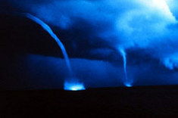

Sea Monster or Spinning Water?

The Loch Ness monster may be nothing more than an overactive column of spinning water. Small whirlwinds, sometimes called 'water devils,' can form over warm water, sucking the water up with them to create a funnel. These water devils can spin around erratically, sometimes making hissing or bubbling noises. These startling sounds combined with the long, neck-like appearance could certainly give anyone nearby the impression that a terrifying sea monster is about to jump out at them.

Sprites, Jets and Elves, Oh My!

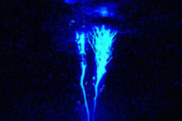

For years, pilots have reported seeing strange colored flashes of light shooting out of the tops of storm clouds, usually to the disbelief of many, But in recent years, scientists have found proof that these strange types of lighting exist. Red [sprites](http://www.livescience.com/forcesofnature/050608_sprites.html) are blasts of red light that soar up to 50 miles above the Earth, usually in clusters of two or more. Their cousins, [blue jets](http://www.space.com/scienceastronomy/planetearth/blue_streak_020314.html), are cones of bluish light that occur lower in the atmosphere than red sprites. Occurring at about the same time as red sprites are elves, a pancake-shaped red glow created by the heat of conventional lightning below. These flashes last only thousandths of a second, and scientists are still investigating exactly what causes them.

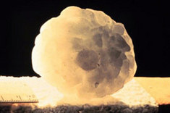

Ice Fall/Bomb

Most people who have been in a strong thunderstorm have experienced hail, the chunks of ice, usually no larger than a softball, that sometimes fall from the storm clouds. But occasionally hailstones far, far larger (one was recorded at 80 pounds) fall from the sky, startling anyone nearby and often shattering into smaller chunks when they hit the ground. More mysterious are the giant chunks that have sometimes plummeted to the ground without a cloud in the sky. While some such events have been chalked up to ice fall off the wings of planes, others still have no explanation as to what caused them.

**Group Project**

1. Think about each of the following types of weather, how does each type affect you? What do you like to do in this type of weather? What type of activities do you do in this weather? Answer these three questions in groups of 2 or 3.
   1. Rainy
   2. Snowy
   3. Scorching
   4. Windy
   5. Foggy

**Homework**

1. Imagine a world without any weather, how would that change our life? Write one page about this?

# Working for a Living

**Pre-Discussion Questions**

1. Are you good at saving money?
2. Where do you work?
3. What is the average salary in your country?
4. If you had to save money, what can you do without?
5. Do you consider yourself a hard worker and why?
6. What do you like about your job?
7. How many hours do you work a week?
8. What do you do for a living?
9. If you had a large amount of money, what would you do with it?
10. How old were you when you earned your first salary?

**Vocabulary**

|  |  |  |  |
| --- | --- | --- | --- |
| Accountant | Decorator | Judge | Surgeon |
| Architect | Garbage man | Miner | Travel Agent |
| Baker | Economist | Optician | TV Cameraman |
| Butcher | Fisherman | Plumber | Vet |
| Caretaker | Hairdresser | Warden | Writer |

**Vocabulary Check Activity**

1. Which of the above jobs is suitable for an outgoing person?
   1. A shy person?
   2. A hardworking person?
   3. A lazy person?
   4. A detailed person?
   5. A logical person?
2. Which of the jobs above are blue collar jobs (蓝领阶层)?
3. Which of the jobs above are white collar jobs?

**Reading (Listening)**

**Terrible Jobs**

|  |
| --- |
| Sewer Cleaner |
| When you think of bad jobs, many people automatically think of jobs that involve human waste, and you can't really be more involved with human waste that a sewer cleaner. However sewer cleaners in the UK and US aren’t as bad as some people think, since you get full protective gear and a very good wage. However things are much different in places like India, where sewer cleaners wear no protective clothing and have to sometimes wade or swim though human excrement, in nothing more than a pair of shorts! Uggh! |
| Police Diver |
| Love the water? Enjoy swimming? Like snorkelling and diving? Well since police diving often involves all of that, then you'll probably love this job. Oh, did we mention that most of the job will consist of being underwater in murky rivers and muddy lakes looking for dead, decomposing human bodies? Ahh, forgot about that. Yes that is essentially what police diving is. Its often described as search and rescue but if the bodies been underwater for several days there isn't going to be much rescuing left to do. |
| Crime Scene Cleaner |
| This particularly disturbing job is rather taxing on the mental stability of the holder. Crime Scene cleaners are in charge of cleaning crime scenes (often murders) after the police are finished with the scene and have collecting all their evidence. Crime scene cleaners often have to clean off blood stains and remove any human remains from the scene and basically return the location to what is what like before the incident. The cleaners will have full protective gear but they still have to see and handle materials that would have most people running out of the door to throw up. |
| Roadkill Cleaner |
| Most people would cross the road to avoid roadkill we see on the road. Be it the gross sight or the unbearable rotting stench, lets face it – roadkill is vulgar. So imagine now that not only did you job involve it, it WAS your job! Roadkill cleaners have to remove all sorts of roadkill from our roads not matter what stage of decomposition they are at. This job needs a severely strong stomach. |
| Coal Miners |
| Okay coal mining has come along way since the early 1900s where it was one of the most dangerous professions in the world which claimed thousands of lives, yet it is still a dirty and dangerous profession. Coal mines contain methane which can cause explosions and miners are often injured or killed from falling rocks. It’s also dirty and coal miners are covered in coal dust when they leave. They also breath in the coal dust with can lead to various lung diseases. |
| Breath Odor Evaluate |
| The job of breath odor evaluator, as you may have guessed, is to smell various cases of bad breath, be in morning breath or breath inflicted with various strong smells like garlic or onion and rate how bad the smell is, and then they smell the breath again after certain odor reducing products had been used like gum or mouthwash. The job role is to effectively test the effectiveness of certain odor reducing products. |
| Fish Gutter |
| Assembly line jobs are never great. Working at the same pace as the conveyor belt next to you is shown to heighten stress levels. Now imagine that not only are you working alongside a conveyer belt but you’re job is taking the fish that are passed to you, opening them up, removing their insides and putting the empty fish back onto the belt. This is the glamorous life of a fish gutter. Extremely smelly and bloody work, and that stench is not easily washed away after you finish for the day! The desk and cubicle all of a sudden looking much more appealing then it did earlier on. |
| Manure Inspectors |
| That's right, manure needs inspecting. You may ask why since manure is … well animal crap, and the answer is that manure is used as a fertiliser but it cannot be used if the animal the manure derived from had certain diseases like E.coli or salmonella. This means the manure inspectors job is to check the manure (and yes that often means elbow deep in it) for any traces of such diseases. Lovely stuff. We all come home from work feeling like crap, but not usuall smelling like it too! |
| Embalmers |
| The job of an embalmer is to prevent the decomposition of a body for a certain amount of time, usually until the funeral of the person so an open casket ceremony is possible. However the job of the embalmer is not pretty. Of course embalmers need to be completely happy working with dead bodies, which alone is a rare quality. Embalmers also need to completely clean dead bodies and drain them of blood, and inject disinfecting embalming fluid into the body. They also need to wire the mouth shut and glue the eyes shut and make the body look nice enough to be viewed, which usually means a little make up and a shave. Some people can do this no problem, but for the majority this job is simply the last thing they could do. |

**Reading Questions**

1. Rank the jobs above from best to worst. Be prepared to defend your answers.
2. What is a job that others might think is terrible but you wouldn’t mind doing?
3. What is a job that others might love to have, but you would never want to have?

**Group Project**

1. Work in groups of 2 to 3 and make a list of the top five jobs in the world. Explain why each of these jobs is so great.
2. The class will divide into two groups, one group are bosses the other group are people trying to get a job. The bosses will have five minutes to prepare interview questions for any job they choose. The other students will have to compete for jobs by answering the interview questions.

**Homework**

1. Write a fake résumé for yourself after you finish college.

# Around Town

**Pre-Discussion Questions**

1. Do you know the neighbors who live near you?
2. Do you know anything fun to do around town?
3. What are some things in town that are part of history?
4. What is the best season in town?
5. What does the town produce?
6. What are the main economical resources in town?
7. What is the average temperature in summer time?
8. If you could change one thing in town, what would you change and why?
9. Can you describe the main geographical features of this town?
10. What is the worst thing happened in town?

**Vocabulary**

|  |  |  |  |
| --- | --- | --- | --- |
| Apartment | Office | Skyscraper | Hardware Store |
| Bar | Park | Fire Station | Grocer’s |
| Car park | Post office | Police station | Shopping Mall |
| cathedral | Restaurant | Railway station | Stationery Store |
| Town Hall | Urban Area | Rural Area | Outskirts |

**Vocabulary Check Activity**

1. Where do you go to get your haircut?
2. Where do you go to send mail?
3. Where do you go to buy food?
4. Where do you go to have a meal prepared for you?
5. Where do you go to meet friends?
6. Where do you go to buy paper?
7. Where do you go you to buy tools?
8. What is the difference between urban areas and rural areas?
9. What is the purpose of having parks in a city?
10. What is the difference between a cathedral and a church?

**Reading (Listening)**

##### Answer Bank

* pool
* restaurant
* gym
* movie theater
* school
* library
* landromat
* church
* park

*Read the following story in English and fill in the blanks with the correct ESL vocabulary word from the list:*

On Saturdays I do not work or go to school, so I usually drive around my town. This is the day that I shop and have fun.

The first place I go to in the morning is the . This is where I like to exercise and take a shower. Next, I go to the to wash my clothes. I don't have a washer in my apartment. Since I am a student, I usually go to the to study a little and find books for my classes. If the weather is nice, I may go to the to walk around in the grass. On really hot days I prefer to go to the town's public for a swim and to see my friends.

On Saturday night I either eat out at a with my friends or I see a film at the . I usually come home early on Saturday night because I need to wake up early the next day to go to . Sunday night is when I do my homework because I have to go to the next day.

Saturday and Sunday are busy days, but I sure have fun. What do you do on the weekends?

**Group Project**

1. With a partner design your own town. One partner speaks the other partner draws what is spoken. After your city is complete switch places, the person that was talking is now drawing and the person that was drawing is now talking.
2. Work with a partner to think of three things that you can do at each of the places around town?
   1. For example: At town hall you can listen to meetings. At the bank you can get a loan.